Lab 7

1. 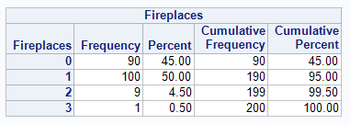
   1. 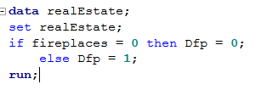
   2. 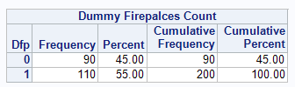
   3. 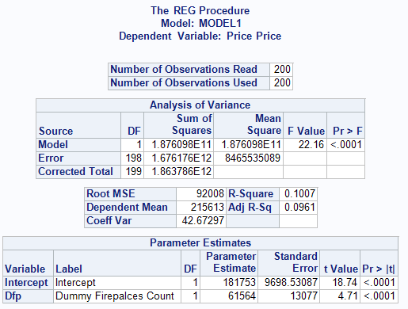
   4. 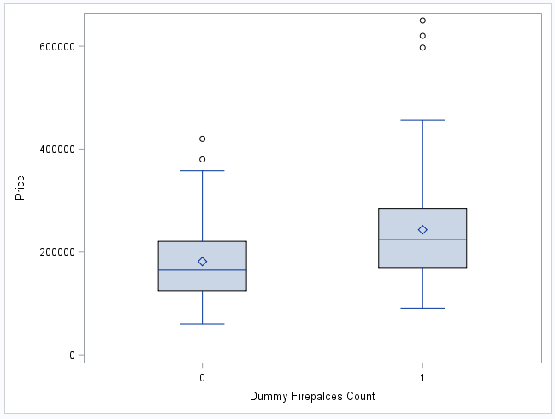
   5. $61,564 difference in average price
   6. 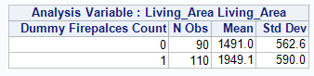
   7. 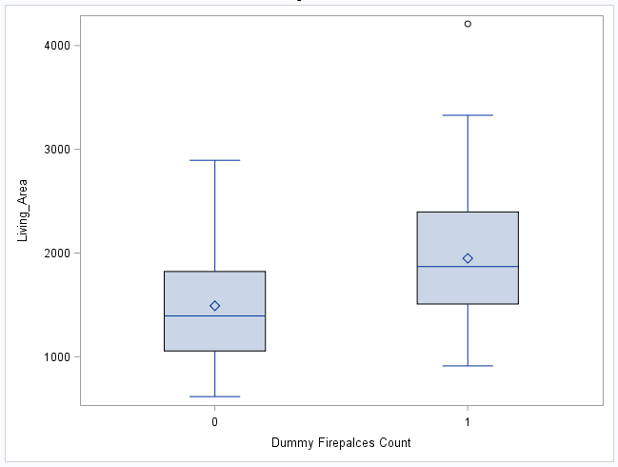
2. 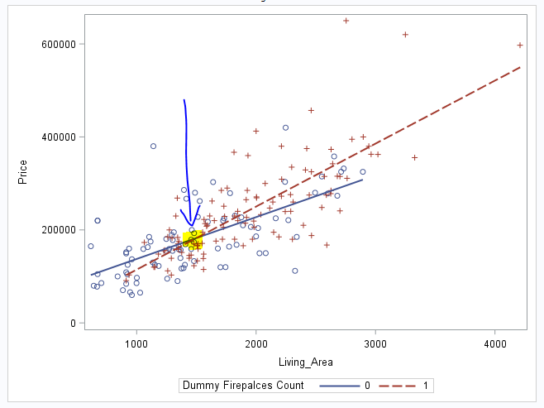
3. If you look at the square feet of a house that has a fireplace, it will usually be higher and the price will be more expensive. This does not mean that the fireplace costs this much, it just means that the average cost of the house is much higher with a fireplace.
   1. Price(hat) = 8639.73 + 8382(Dfp) + 116.10(Living_area)
   2. 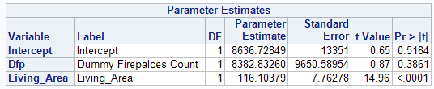
      1. Price(hat) = 8639.73 + 116.10(Living_area)
      2. Price(hat) = 17021.73 + 116.10(Living_area)
   3. 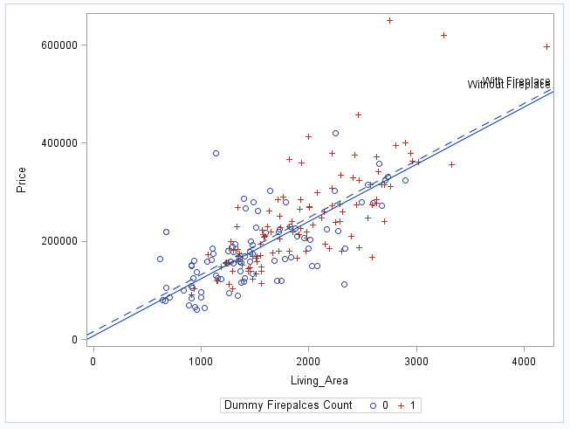
   4. Slope of living_area is 116.10 meaning for every 1 square foot, the price goes up $116.10
   5. The slope of Dfp is 8382 which means a house with one fireplace will cost, on average, roughly $8382 more.
   6. Dfp
   7. This is because you are taking into consideration square feet of a house instead of just taking the difference of the two averages.
   8. With a t-value of 14.96 and the p value for Living_area being <.0001, this means there is statistically significant evidence that the living_area is useful in predicting the price.
   9. With a t-value of 0.87 and the p value being 0.3861, this means that there is not statistically significant evidence that the fireplace count affects the price when the square feet is in the model.
   10. We are 95% confident that the average slope of the square feet model is between 8636.72 and 9650.58
4. 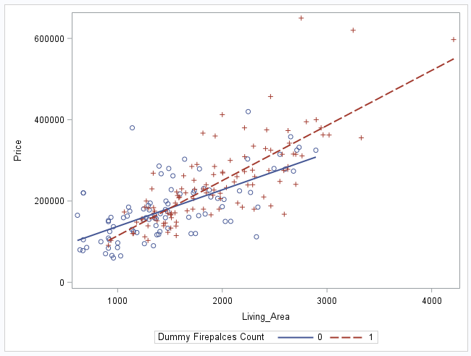
   1. Price(hat) = 8639.73 + 116.10(Living_area)
   2. Price(hat) = 17021.73 + 116.10(Living_area)
   3. 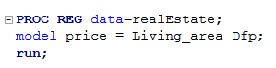
   4. Price(hat) = 8639.73 + 8382(Dfp) + 116.10(Living_area)
      1. Price(hat) = 8639.73 + 116.10(Living_area)
      2. Price(hat) = 17021.73 + 116.10(Living_area)
   5. If there is no fireplace, then the slope would be 0 for sqft * Dfp but if there was at least one fireplace, then sqft * Dfp = 972312
      1. Root MSE for 0 fireplaces = 58855 and Adj R-Sq = 0.42
      2. Root MSE for 1+ fireplaces = 0.6092 and Adj R-Sq = 0.6056
   6. The model that has lines with difference slopes because if you have a fireplace, your slope would be 17021 and without, your slope would be 8639